26(B). In pl/sql viewing in-out parameter in application express .

Create table:

CREATE TABLE contacts (

contact_id NUMBER PRIMARY KEY,

name VARCHAR2(100),

phone_no VARCHAR2(15)

);

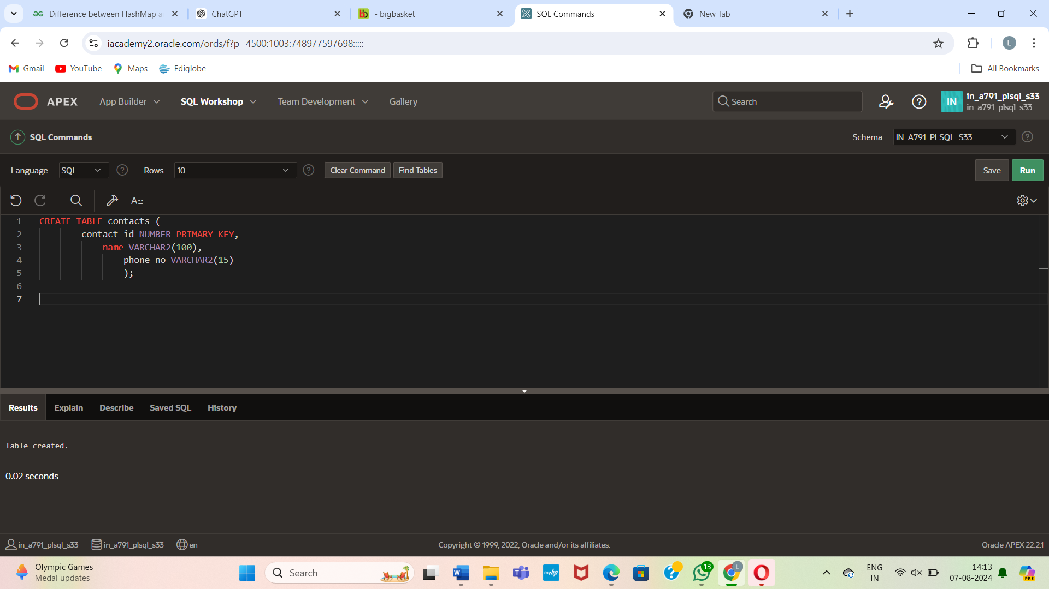

Insert some sample data into the **contacts** table:

INSERT INTO contacts (contact_id, name, phone_no) VALUES (1, 'John Doe', '1234567890');

INSERT INTO contacts (contact_id, name, phone_no) VALUES (2, 'Jane Smith', '2345678901');

INSERT INTO contacts (contact_id, name, phone_no) VALUES (3, 'Alice Johnson', '3456789012');

COMMIT;

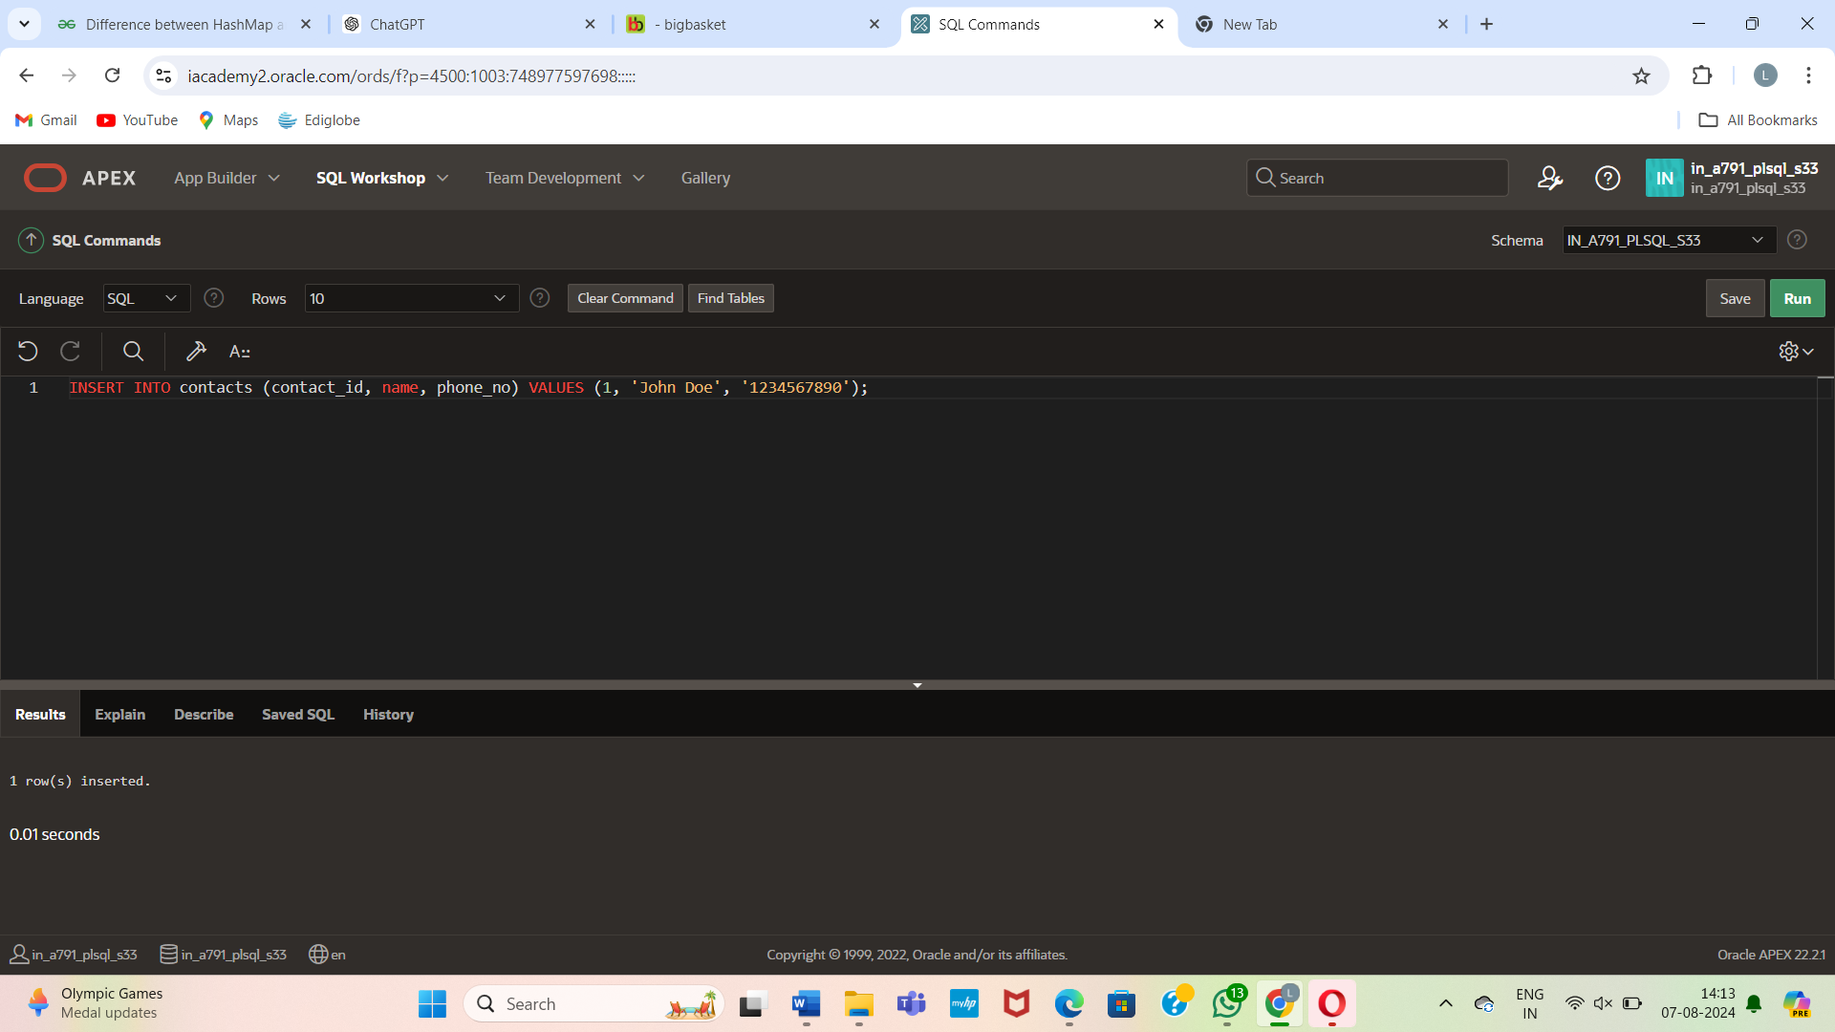

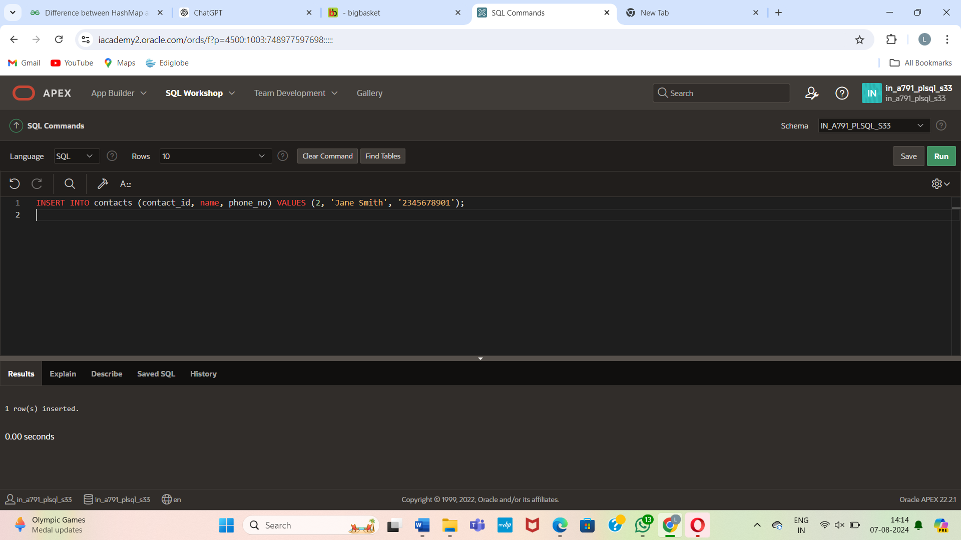

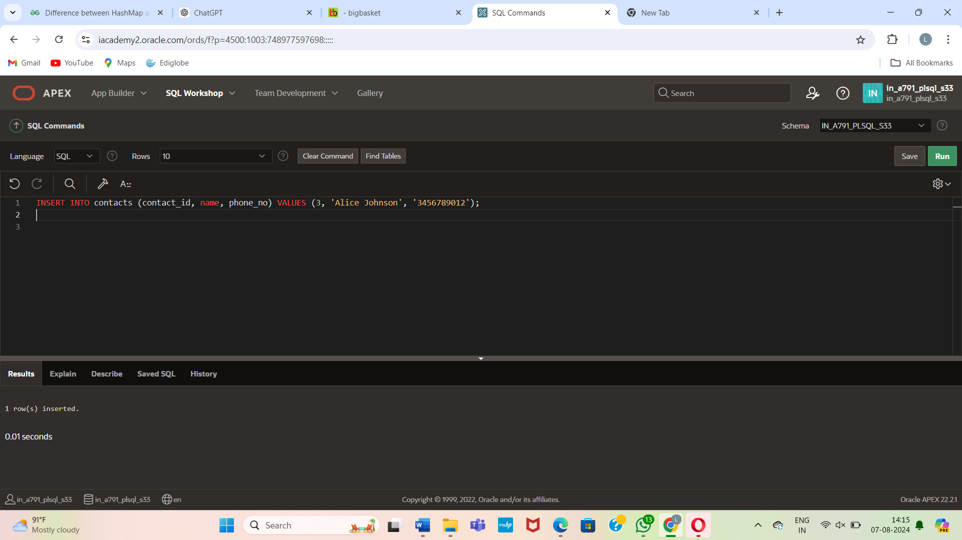

Now, create the **format_phone** procedure as you provided:

CREATE OR REPLACE PROCEDURE format_phone

(p_phone_no IN OUT VARCHAR2) IS

BEGIN

p_phone_no := '(' || SUBSTR(p_phone_no, 1, 3) ||

')' || SUBSTR(p_phone_no, 4, 3) ||

'-' || SUBSTR(p_phone_no, 7);

END format_phone;

/

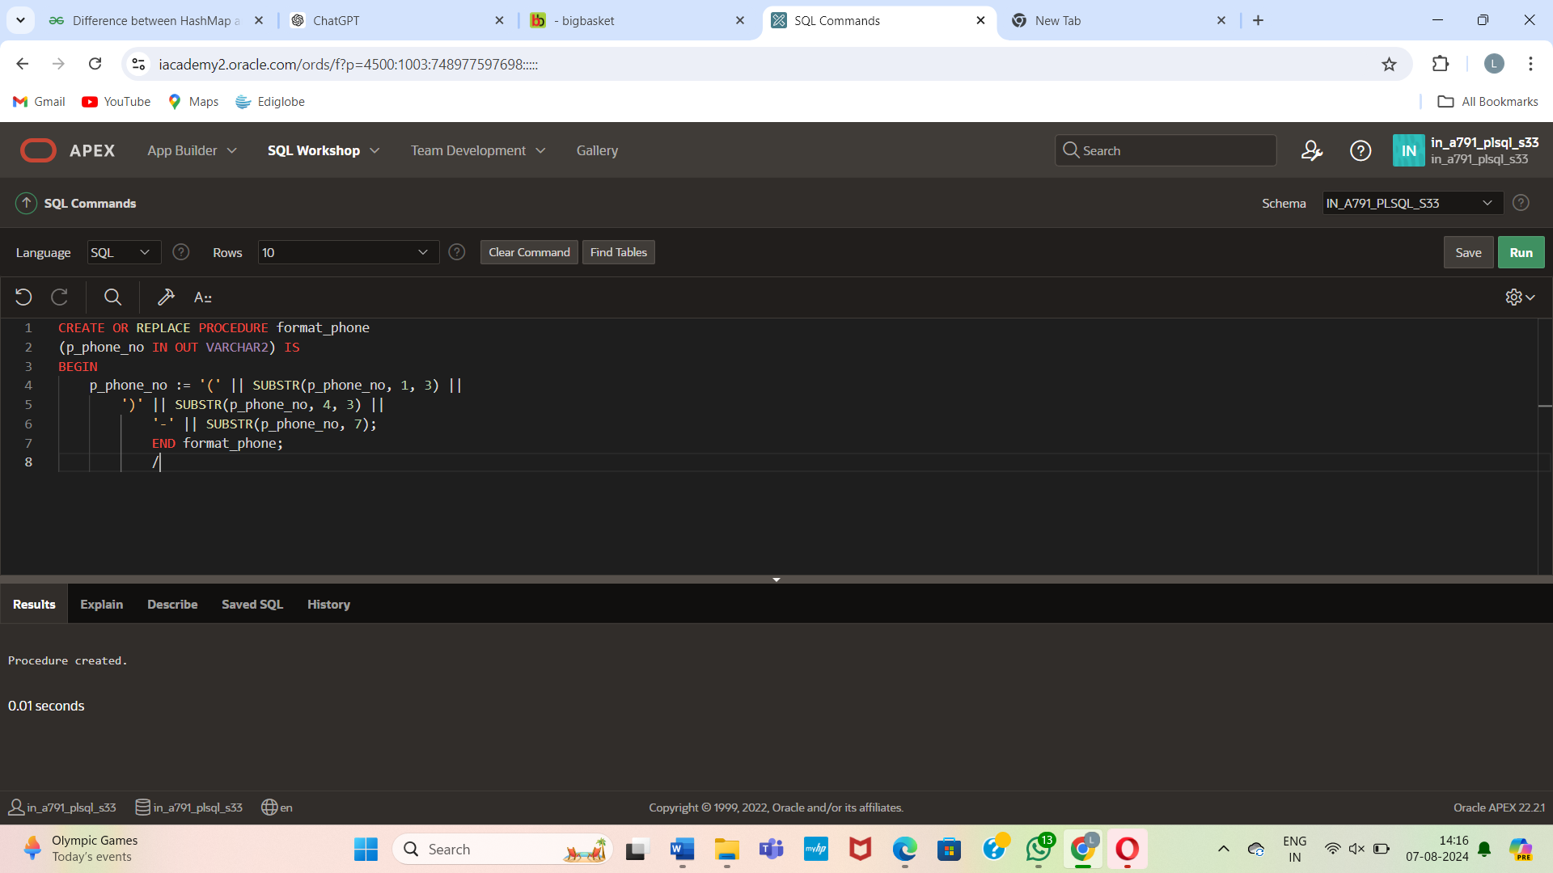

Here's an example PL/SQL block to do that:

DECLARE

l_phone_no VARCHAR2(15);

BEGIN

FOR rec IN (SELECT contact_id, phone_no FROM contacts) LOOP

l_phone_no := rec.phone_no;

format_phone(l_phone_no);

UPDATE contacts

SET phone_no = l_phone_no

WHERE contact_id = rec.contact_id;

END LOOP;

COMMIT;

END;

/

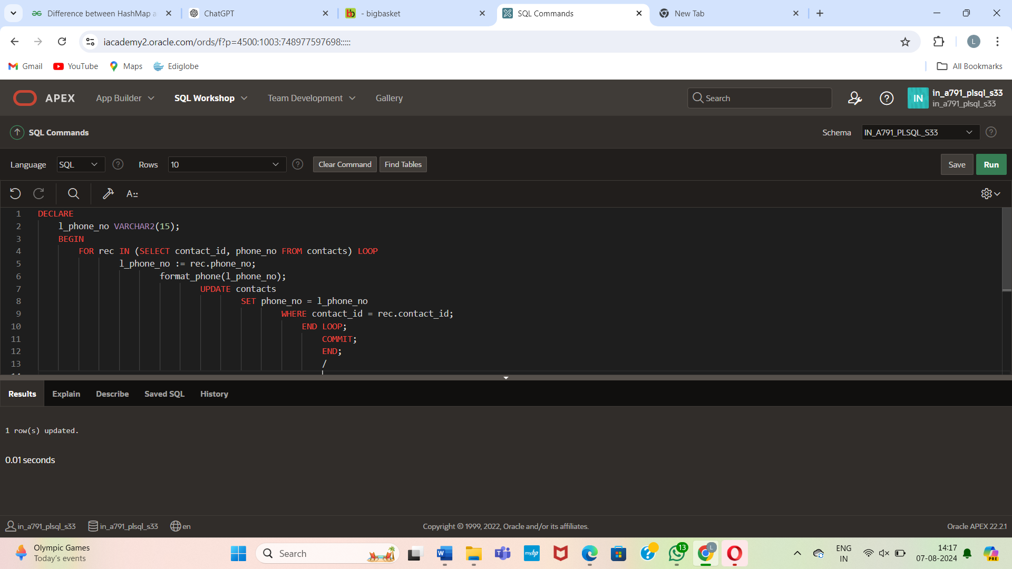

SELECT * FROM contacts;

